Name: Sylvia Le

Course: COM219

**Homework 5**

Question 3

1. The truth table for 8x1 MUX

|  |  |  |  |
| --- | --- | --- | --- |
| **S2** | **S1** | **S0** | **Out** |
| 0 | 0 | 0 | I0 |
| 0 | 0 | 1 | I1 |
| 0 | 1 | 0 | I2 |
| 0 | 1 | 1 | I3 |
| 1 | 0 | 0 | I4 |
| 1 | 0 | 1 | I5 |
| 1 | 1 | 0 | I6 |
| 1 | 1 | 1 | I7 |

* The 8x1 MUX has 3 select lines, 4x1 has 2 select lines.

→ If 8x1 is built from 4x1, and every select lines are independent, then there will be 4 select lines (which is supposed to be 3)

→ Choose one of the select line to wire to the enabler, which will then disable either one of the two 4x1 MUX to deliver the output

* The circuit:

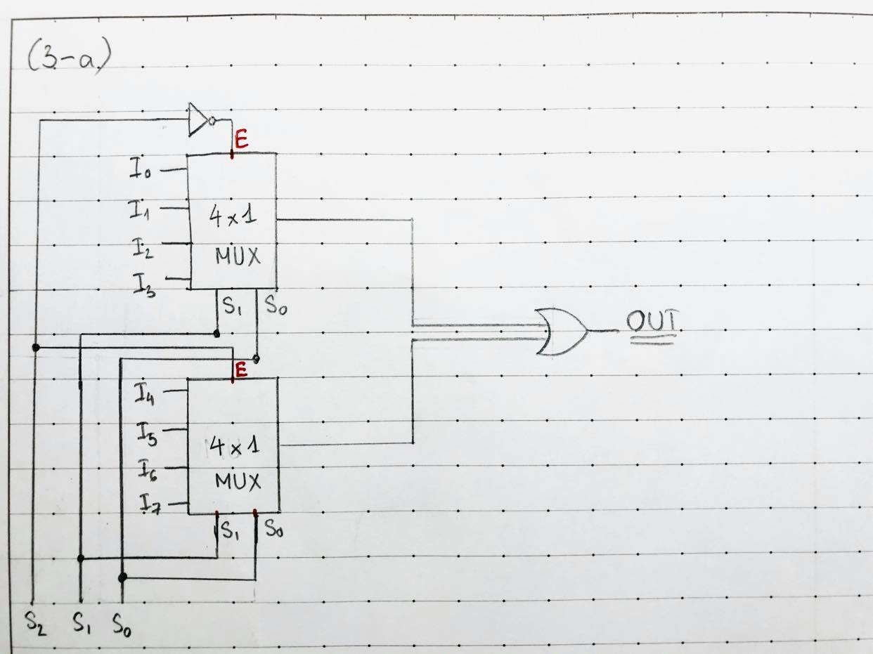

* Explaination for one case, where output = I0

+ According to the truth table, S0 = S1 = S2 = 0

+ S2 wire to the enabler of the two MUX. S2 go through an inverter before connecting to the enabler of the 1st MUX (the one above)

+ S2 = 0 → 1st MUX enabler = 1, 2nd MUX enabler = 0

→ 1st MUX is enabled, 2nd MUX is disable

+ In the 1st MUX, S1 and S0 = 0 select the data line I0 as output

+ In the 2nd MUX, since it’s disabled, the output is 0

+ Output of the 2 MUX is ORed to give the final output: I0 + 0 = I0

→ Gain the desired output

1. Truth table:

|  |  |  |  |  |
| --- | --- | --- | --- | --- |
| **B1** | **B0** | **A1** | **A0** | **A >= B?** |
| 0 | 0 | 0 | 0 | 1 |
| 0 | 0 | 0 | 1 | 1 |
| 0 | 0 | 1 | 0 | 1 |
| 0 | 0 | 1 | 1 | 1 |
| 0 | 1 | 0 | 0 | 0 |
| 0 | 1 | 0 | 1 | 1 |
| 0 | 1 | 1 | 0 | 1 |
| 0 | 1 | 1 | 1 | 1 |
| 1 | 0 | 0 | 0 | 0 |
| 1 | 0 | 0 | 1 | 0 |
| 1 | 0 | 1 | 0 | 1 |
| 1 | 0 | 1 | 1 | 1 |
| 1 | 1 | 0 | 0 | 0 |
| 1 | 1 | 0 | 1 | 0 |
| 1 | 1 | 1 | 0 | 0 |
| 1 | 1 | 1 | 1 | 1 |

* Divide the 16 rows of the truth table into pairs of 2 rows, we see: the output of each row is either all 1, all 0 or is equal to A0
* Choose B1, B2, A1 as the select lines. There can be 8 different combinations, each map to one data line (denoted by different colours in the table above)

